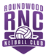
Roundwood Netball Club Kit Guidance for Seniors and Development Squad
All kit must be purchased online by our members via the Roundwood club page at our supplier, SilverFx https://silverfx.co.uk/category/sports-clubs/roundwood-netball-club/
Any purchases of kit are in addition to your monthly club subscription. Please refer to the notes below for which kit items are required or optional.
ORDERING KIT
You as the individual must place and pay for the order. To do this you will need to register your own account on the Silverfx website.
You have the choice of either ordering items to arrive as part of a club delivery (which have lead times of approximately 6 weeks from each club order deadline), or as an express order. This season’s club order deadlines are:
Club order deadline | Estimated delivery date
26 June 2020 | 24 August 2020
24 August 2020 | 19 October 2020
20 October 202 | 14 December 2020
11 January 2021 | 8 March 2021
8 February 2021 | 5 April 2021
5 April 2021 | 7 June 2021

If you select ‘Club delivery - Free’ your order will be part of a bulk delivery to the kit secretary on or near the estimated delivery date. She will then distribute items at the next training session. Alternatively, you can pay extra for SilverFx to dispatch your order directly to your address on the same day as they dispatch the club delivery to the kit secretary.
A selection of our kit items are also available in the express delivery section of our club page. These can be ordered at any time for delivery to your address in 3 to 5 working days.
Items in the express section cost £1 more than the equivalent item in the standard section (to cover SilverFx’s admin time to process the order) and you also pay a delivery cost for Royal Mail delivery to your home.

Orders from this section need to be placed separately to those made for items from the main section.

REQUIRED KIT

Players in squads for B to E teams (for which you need to be aged 14 and to have been selected for a squad by Roundwood coaches) should wear a Roundwood Netball dress (or Roundwood playing shirt/vest & skirt/skort) on match days. This is termed ‘Netball Dress’ on the website. Do not order the ‘A team dress’ in the Regional section on our SilverFx page as this is only for players in our top team.
The A team have a different design of dress to the other teams. Whilst this is available on SilverFx under the ‘Regional’ section of our club page, please speak to your captain, or Sara Palmer (Club Secretary) or Lucy Hill (Kit Secretary) before ordering one because we have a small stock of A team dresses available to purchase from us.

Individual name on rear of dress is optional but encouraged.

RECOMMENDED KIT

We recommend that players in squads for B to E teams and Development Squad have a Roundwood hoodie or jacket to keep warm because your matches are played outside.
OPTIONAL KIT
All members. All other items are optional. However, when representing your club please make the effort to wear any appropriate optional club items that you have in preference to other sportswear. This ensures that our teams look smart and cohesive at matches and events.

Please don’t wear non-club colours on court in either your baselayers or shorts.

On match/tournament days, we prefer you to wear white rather than black underskins. The branded baselayer available in the kit is one option for you, but you could wear a plain white one instead.

Leggings worn for matches or tournaments should be black.

Undershorts should be purple (one option available on Silverfx) or black.

Development Squad members who are not in a senior team squad may like to wear the following to weekly training:

- The Roundwood training top (white t-shirt with RNC logo - Individual name on back optional but encouraged)
- Roundwood skort.
Development Squad members may be asked to represent the club at age appropriate tournaments. At these we aim to use the Velcro bibs that attach to club dresses/playing shirts/vests (rather than overhead bibs). However, it is not essential for you to own one of these because we often have some that can be borrowed.

KIT ITEMS AVAILABLE
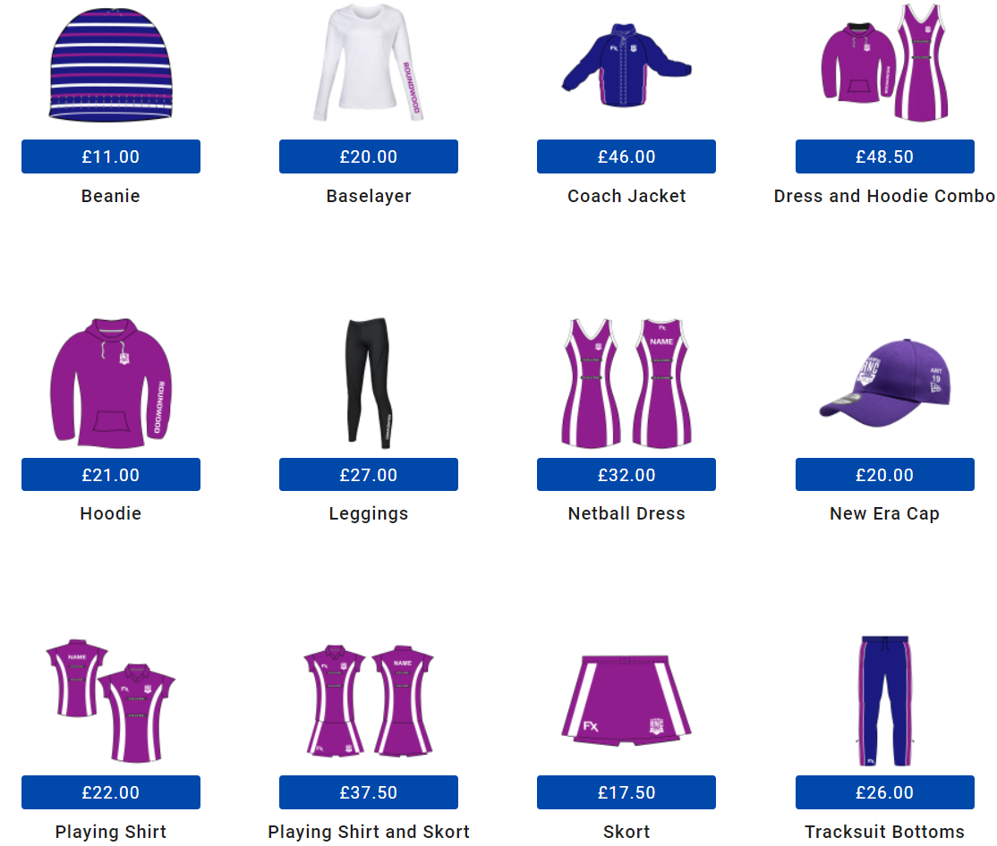

CLUB KIT SECRETARY
If you have any questions about the kit or ordering process please contact our Kit Secretary Lucy Hill via roundwoodkitsecretary@hotmail.com or via the Development Squad WhatsApp group, phone number ending 251. Players in A to E team, ask your Captain or Sara Palmer for Lucy’s number.

FURTHER INFORMATION:

Personalisation
There is an additional £3 for personalisation of training tops, dresses, playing shirts, vests and hoodies. Adding your name to the back of your garment is encouraged but not compulsory. It will appear in capital letters.

Sizing
The club is not responsible for what size of kit you order. Please use the guidance on the website and choose the drop-down boxes carefully when ordering. We recommend trying someone else’s kit for size if you are not sure which size to order. The club WhatsApp groups are useful for requesting this. Please be aware that some members’ dresses may have come from a previous supplier and that the measurements vary e.g. the length of a short SilverFx dress is 30” whereas the length of a short Kukri (previous B to E team dress supplier) or Viper10 (previous A team dress supplier) dress was 31”
Top tip
If you wear smaller sizes of kit, you may wish to order via the junior section of our site which has the same items available at slightly lower prices. The only differences are that the junior training top has a slightly different cut and the junior hoodie has no pull strings around the neck.

Club orders for free delivery. We have found that when you get your order confirmation their system seems to pick up your home address to be one of the fields on your confirmation, but so long as you have selected club delivery – free, it will come to the central club delivery address.

Earning points
You will see on the Silverfx website that for each £1 that you spend you earn 1 ‘bonus point’. Each point equates to 1p to discount against a future purchase within 12 months.
Account expiry
I have found through personal experience that Silverfx delete your account if it has been inactive for a certain period (possibly 2 years). If these circumstances apply to you it means that you will need to recreate an account at check out page when you create an order.
Coach jacket
This is a warm, padded jacket. Ideal for spectators! For players, we recommend instead one of the waterproof jackets (available in a choice of fleece or mesh lined via a dropdown box on the item) because they are more suitable to wear during warm up/training in wet conditions.

Nearly New items
Occasionally we have some nearly new items available for purchase direct from the club. Ask the coaches at training or check our club website on the kit page to see if we are currently advertising any. https://roundwoodnetballclub.co.uk/kit

