Roundwood Netball Club Kit Guidance for Juniors and Little Rs
All kit must be purchased online by our members via the Roundwood club page at our supplier, SilverFx https://silverfx.co.uk/category/sports-clubs/roundwood-netball-club/
Any purchases of kit are in addition to your monthly club subscription. Please refer to the notes below for which kit items are recommended or optional.
ORDERING KIT
You as the individual must place and pay for the order. To do this you will need to register your own account on the Silverfx website.
You have the choice of either ordering items to arrive as part of a club delivery (which have lead times of approximately 6 weeks from each club order deadline), or as an express order. This season’s club order deadlines are:
Club order deadline | Estimated delivery date
26 June 2020 | 24 August 2020
24 August 2020 | 19 October 2020
20 October 2020 | 14 December 2020
11 January 2021 | 8 March 2021
8 February 2021 | 5 April 2021
5 April 2021 | 7 June 2021

If you select ‘Club delivery - Free’ your order will be part of a bulk delivery to the kit secretary on or near the estimated delivery date. She will then distribute items at the next training session. Alternatively, you can pay extra for SilverFx to dispatch your order directly to your address on the same day as they dispatch the club delivery to the kit secretary.
A selection of our kit items are also available in the express delivery section of our club page. These can be ordered at any time for delivery to your address in 3 to 5 working days.
Items in the express section cost £1 more than the equivalent item in the standard section (to cover SilverFx’s admin time to process the order) and you also pay a delivery cost for Royal Mail delivery to your home.

Orders from this section need to be placed separately to those made for items from the main section.

RECOMMENDED KIT
We recommend that Juniors and Little Rs wear the following to weekly training (and also for matches where applicable):

- The Roundwood training top (white t-shirt with RNC logo - Individual name on back optional but encouraged)
- Roundwood skort.
OPTIONAL KIT
All other items are optional. However, when representing your club please make the effort to wear any appropriate optional club items that you have in preference to other sportswear. This ensures that our teams look smart and cohesive at matches and events.

KIT ITEMS AVAILABLE
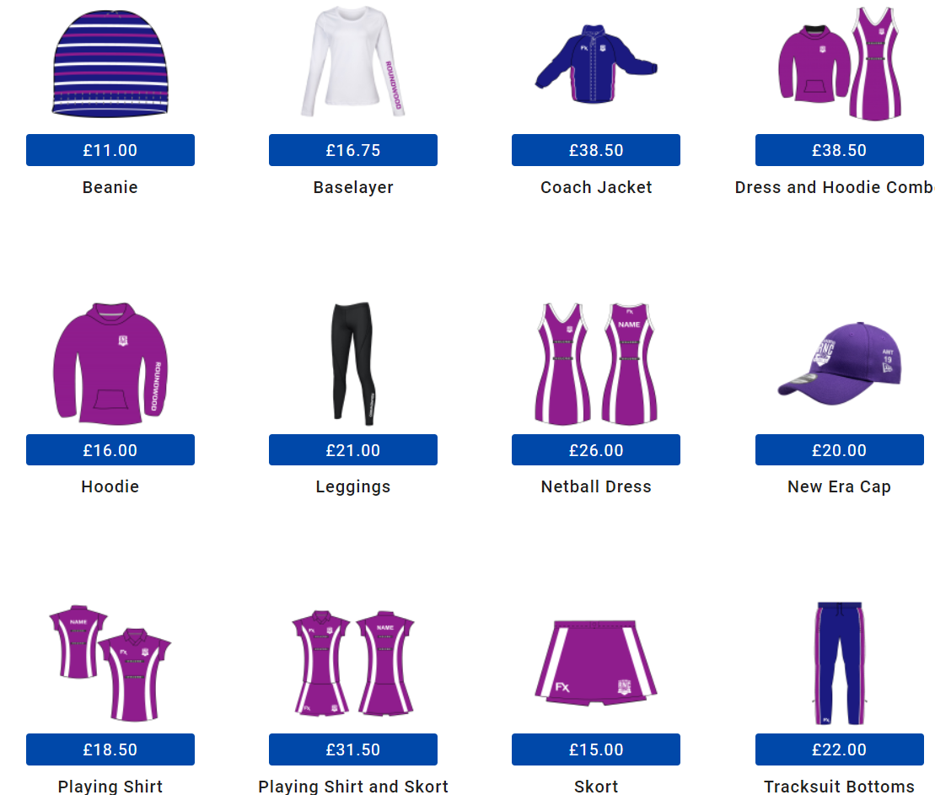
Note - There is an additional £3 for personalisation of training tops, dresses, playing shirts, vests and hoodies. Adding your name to the back of your garment is encouraged but not compulsory

CLUB KIT SECRETARY
If you have any questions about the kit or ordering process please contact our Kit Secretary Lucy Hill via roundwoodkitsecretary@hotmail.com or via the Junior or Little Rs WhatsApp group, phone number ending 251.

FURTHER INFORMATION:

Sizing
The club is not responsible for what size of kit you order. Please use the guidance on the website and choose the drop-down boxes carefully when ordering. We recommend trying someone else’s kit for size if you are not sure which size to order. The club WhatsApp groups are useful for requesting this.
If you require larger sizes than are available on the junior section of our site, you can select from the senior section instead. Note that prices are higher in the senior section.
Club orders for free delivery. We have found that when you get your order confirmation their system seems to pick up your home address to be one of the fields on your confirmation, but so long as you have selected club delivery – free, it will come to the central club delivery address.
Earning points
You will see on the Silverfx website that for each £1 that you spend you earn 1 ‘bonus point’. Each point equates to 1p to discount against a future purchase within 12 months.
Account expiry
I have found through personal experience that Silverfx delete your account if it has been inactive for a certain period (possibly 2 years). If these circumstances apply to you it means that you will need to recreate an account at check out page when you create an order.
Coach jacket
This is a warm, padded jacket. Ideal for spectators! For players, we recommend instead one of the waterproof jackets (available in a choice of fleece or mesh lined via a dropdown box on the item) because they are more suitable to wear during warm up/training in wet conditions.

Nearly New items
Occasionally we have some nearly new items available for purchase direct from the club. Ask the coaches at training or check our club website on the kit page to see if we are currently advertising any. https://roundwoodnetballclub.co.uk/kit

